Brett Stelly

Rendering Geometry

**Ability to load shaders from file using a Shader class object.**

This is a picture of my shader class. This class contains:

* Constant char pointers for the vertex and fragment shader file sources
* Unsigned ints for the vertex and fragment shaders
* Strings to store all of the text in the vertex and fragment shader file sources
* Unsigned int for the shader program

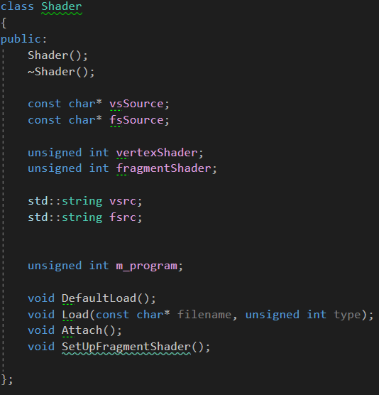

Load should be called twice. Once to load the vertex shader, and again to load the fragment shader. If a ‘1’ is passed in as a second argument, then a vertex shader will attempt to be loaded. If a ‘2’ is passed in as the second argument, then a fragment shader will attempt to be loaded.

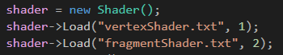

When Load is called, the file is read and stored in a variable. The shader class’s “vsrc” and “fsrc” variable store the file’s contents. Depending on the unsigned int passed in, the shaders vsource or fsource member variables will be assigned the contents of the file.

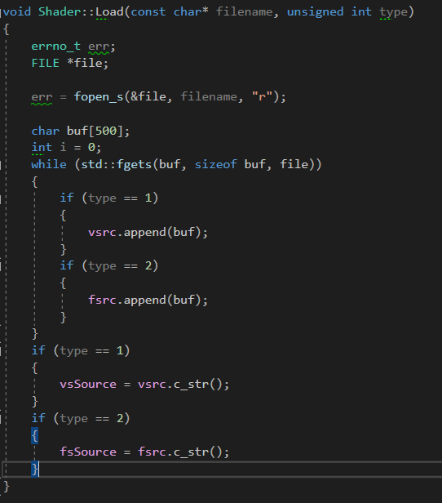

Once both vertex and fragment shaders are loaded, I call the shaders Attach function to compile the shaders.

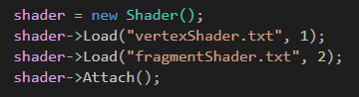

The Attach function compiles the information stored in the vsource and fsource member variables. A new program is created. This program is the shader program with the vsource and fsource shaders compiled. Once the program is created the shaders are attached to it and the program is linked to the whole application.

